 | Chiorino America Distributor News |  |  |  | Q3 2019

Chiorino America at IBIE
We are gearing up for the International Baking Industry Expo in Las Vegas which will take place Sept 8-11. The Expo is promoted as the “most comprehensive baking industry event in the Western Hemisphere” and takes place every three years. Over 23,000 baking professionals are expected to attend.  This is certainly one time where we won’t say “what happens in Vegas, stays in Vegas”. We expect to generate a number leads to bring back to work on together with our Distributor partners.  Stop by and see us in Booth 4753 where we plan to promote our numerous problem solving solutions for bakers, from our acclaimed HP series with higher temperature & oil/chemical |  |  | resistance, to frayless types, our Dehesive line, DET detectable belts, new UV-C resistant types and HP Compact Drive positive drive belts which were awarded IBIE's prestigious “best in baking” award at the last Expo.  We hear of increasing concerns with allergens from producing multiple products on the same line and higher oven temperatures to increase throughput as a some of the causes of “pains” for bakers today. https://www.youtube.com/watch?v=SXJzub5vJ3U  Our industry leading HP product line is the perfect solution for both of these pains with it’s elevated temperature & stain resistance and the easier to clean surface.  We also hear of concerns over foreign object contamination causing product recalls. This is resulting in a strong positive trend in the sales of our DET range of belts, guides, cleats, and round belts. |  | HISTORY CORNER  Did you know that Chiorino HP Compact Drive products were awarded a Certificate at the last IBIE qualifying for the B.E.S.T. in Baking Program in terms of Sustainability and Cost of Ownership Optimization?  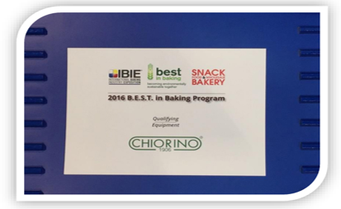  As part of a commitment to positive transformation in the world, the IBIE, together with Snack Food & Wholesale Bakery identified sustainability as one of the industry’s top priorities and the award recognizes suppliers that foster energy conservation, reduced water usage and / or a reduction of the overall impact on the environment.
Meet The TEAM

Our Suwanee facility continues in the growth phase with the addition of a new 2 meter wide v-guide machine with the capability of applying two guides in one pass. The machine is in the final phase of testing and will be fully operational soon.

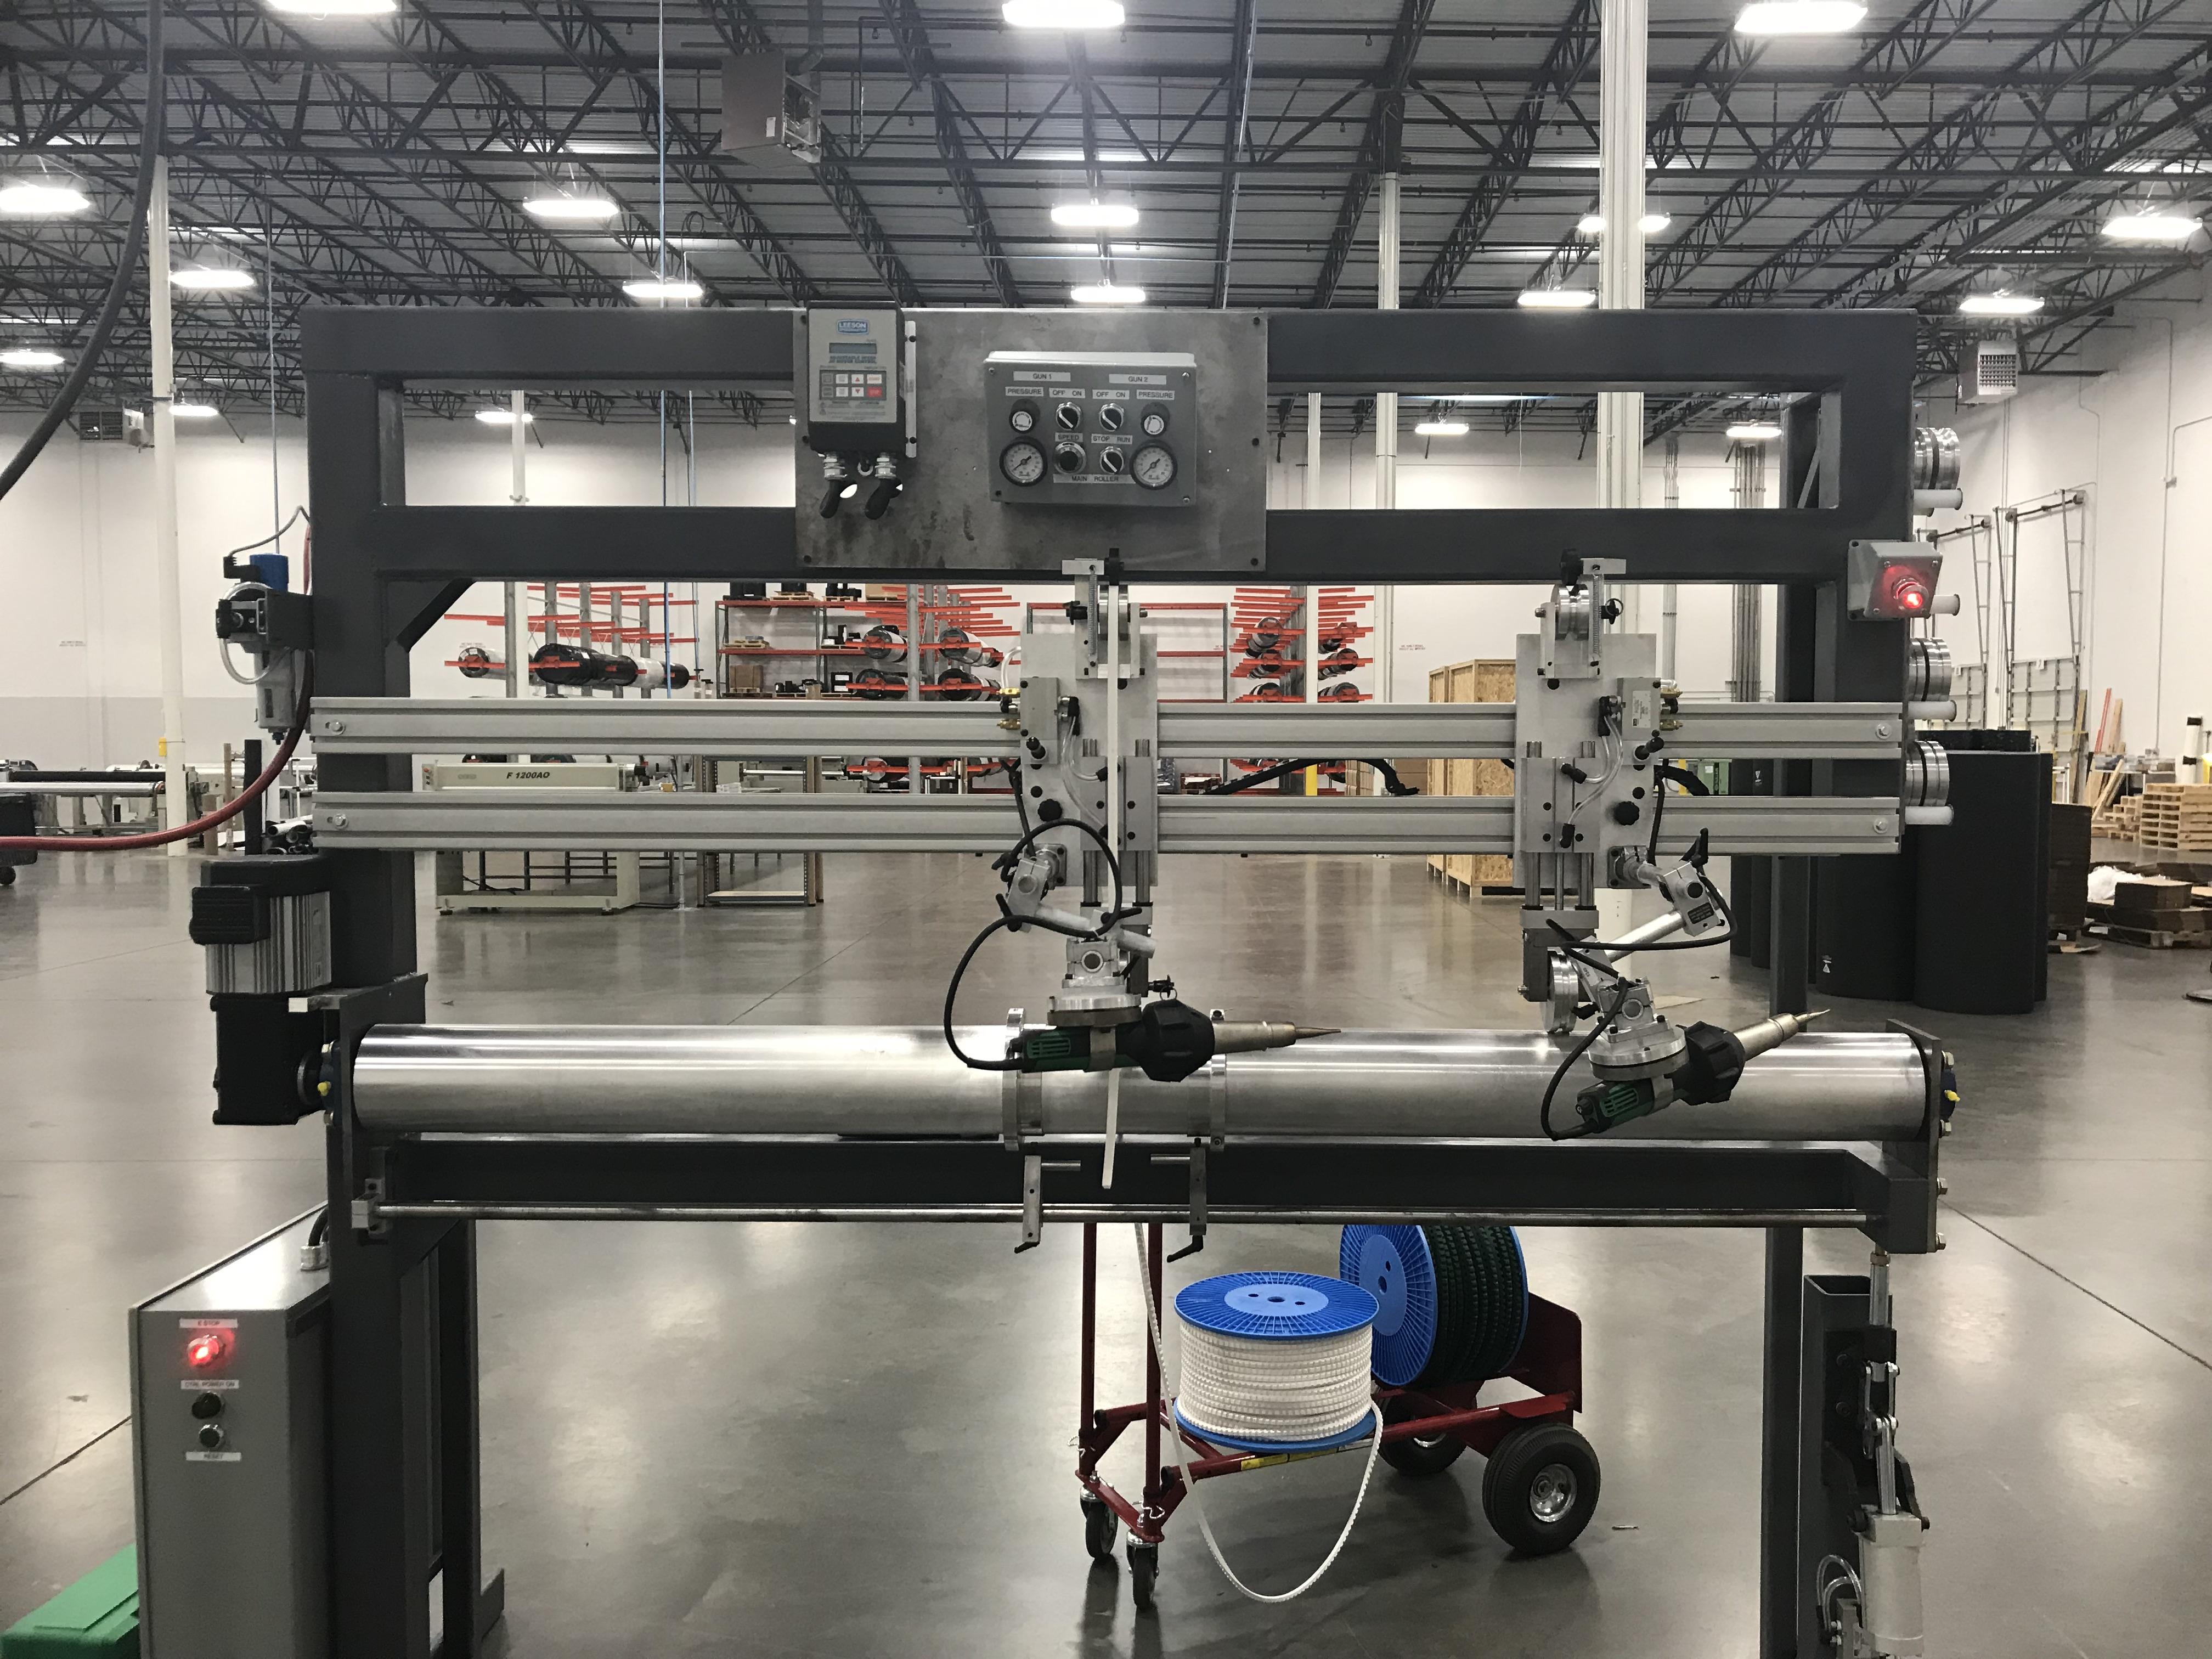
Since the last newsletter we continue to build inventory of full rolls of belting materials and accessories (cleats, guides, films, etc) in support of one of our foundational tenets – to have the right products in inventory and in the right quantity, to minimize/eliminate stock outs.

We also added an additional Fabrication team member and are interviewing for the next one.

Equipment upgrades in Newark, DE and Dallas, TX have also moved forward, in the past quarter, as we commissioned: 3 new presses, a 2 meter slitter and a new 2 meter finger puncher in Newark and a new 2 meter press in Dallas.
Chiorino America Suwanee Facility
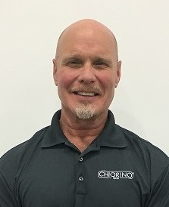
Ken Balogh
Meet Ken Balogh, our Key Account Manager for OH, KY and IN. who recently celebrated his 30th anniversary with the Chiorino Team!
His interests outside of work are beach vacations, traveling, spending time with his 3 grandkids, golfing and exercising (weight lifting).
Kenny attended Ohio State University on a Baseball Scholarship and graduated in 1981. He remains a huge Buckeyes fan as you might expect.
He has two children, a daughter Kelsey (33) that works for non-profit, Juvenile Diabetes Research Foundation and a son, Brett (31) who is a firefighter/paramedic in Columbus Ohio.
He has been married to his wife Debbie for 35 years. She has been the HR manager for JM Smucker Company in Cincinnati, Ohio for the past 25 years.
Kenny & Debbie have 3 grandkids: Carson 7, Caleb 5 and Camden 3, and enjoy spending time with them and especially taking them on beach vacations.

APPLICATION FOCUS
Product recalls in the food industry continue to make news as foreign objects are found in everything from chicken nuggets to cookies and pasta boxes.
Chiorino’s DET detectable product range is a value-added solution to help food processors guard against product recalls and negative publicity if a section of the conveyor belt, v-guide, cleat or sidewall becomes detached from the belt and gets into the food, during normal operations.  Chiorino’s DET products can be detected in about 1/3 the size of most competitors due to the use of very small particles and extremely even dispersion in the thermoplastic materials as a | result of Chiorino’s superior mixing and processing technologies.  We get asked “what size of material can be detected?” We can’t provide an exact size that can be detected because of differences in metal detectors and sensitivity levels used but recommend you take some sample material in for actual testing and comparison.  The Chiorino DET range is the broadest in the industry and is accompanied by a full line of round belts, guides, sidewalls and cleats. |  | Check out the DET video on our YouTube channel: https://youtu.be/w1soaUGtWlY  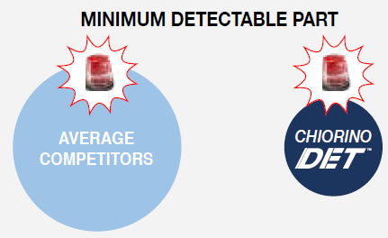  And download the brochure from our website: https://www.chiorino.com/public/files/Chiorino_DETECTABLE_BELTS-EN.pdf
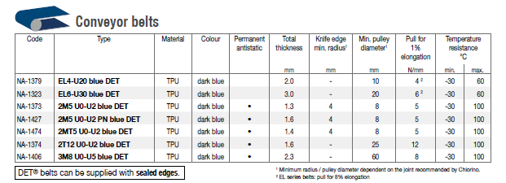
Chiorino America  255 Satellite Blvd NE Ste 100 | Suwanee, GA |30024  125 Ruthar Drive | Newark | DE | 19711  11220 Grader Street Ste 200 | Dallas | Texas | 75238 | For Customer Service and inquiries  302-292-1906  info@chiorino.us  www.chiorino.us  www.linkedin.com/company/chiorino-america/

