 | Chiorino America Distributor News |  |  | Q2 2019

Chiorino AMERiCA 1st CDTS In the Books
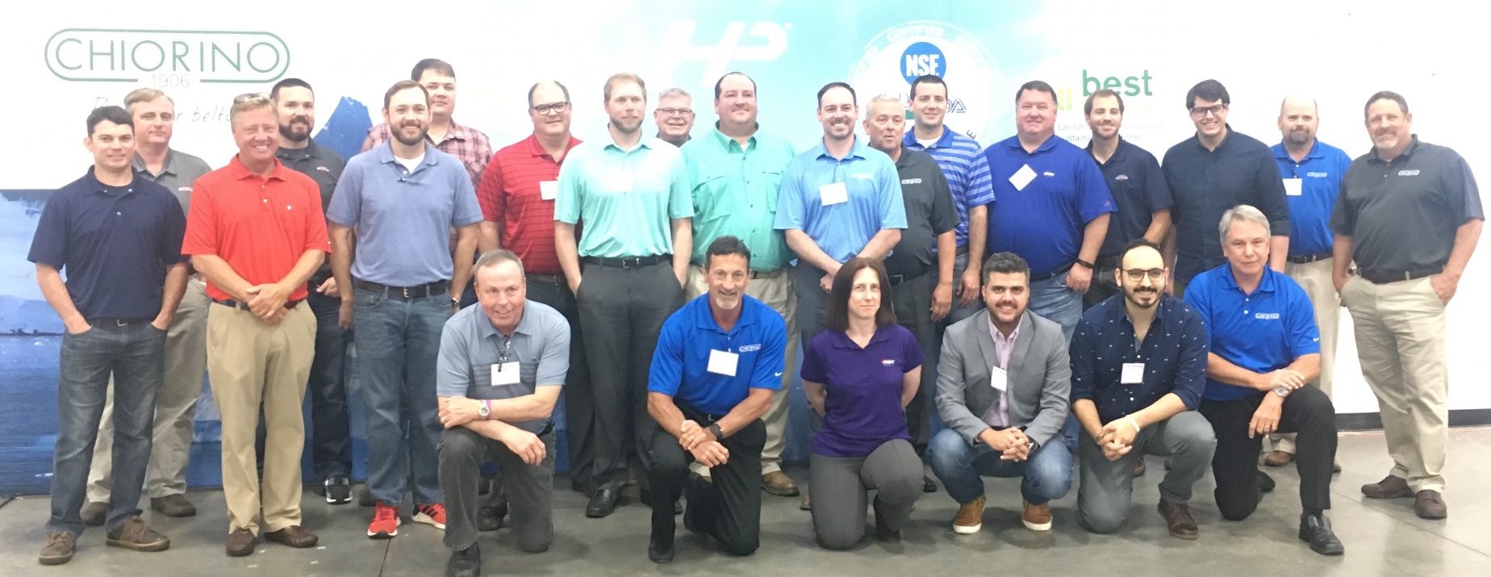  Our first Chiorino Distributor Training School (DTS) was held in May and was “sold out”. The 2-day event was hosted in our new facility in Suwanee, GA, just outside Atlanta.  Topics covered over the two days included: a company overview, basics of belting, an in-depth presentation of our products for wet and dry food processing, printing/paper/packaging and material handling (major focus Warehouse & Distribution Centers). We also provided an introduction to products for wood, automotive and textile.  A portion of the training was dedicated to touring the new facility and reviewing equipment capabilities and state of the art tools offered for field splicing. |  |  | We had some very positive feedback from class attendees:  “I learned invaluable information about products, specifications and applications.”  “Without question, this was the best I have attended.”  “Chock full of very useful information, very well organized and structured, time well spent.”  We are considering adding a 2nd School in the Fall due to the popularity of the first one. If you have interest in attending, please let your Key Account Manager know or email: b.hornsby@chiorino.us.  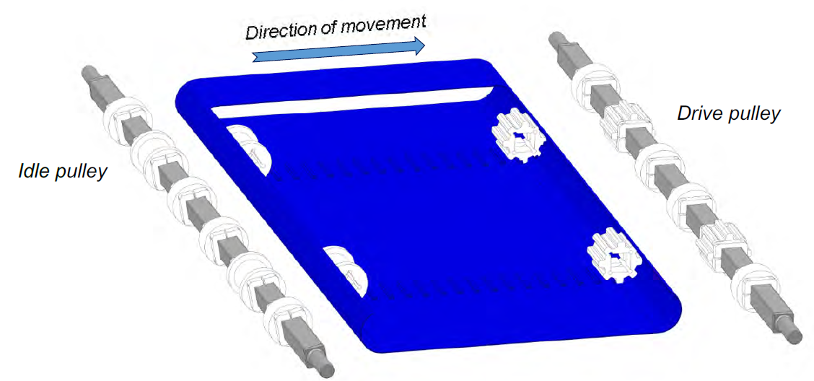 | HISTORY CORNER  Did you know that Chiorino promotes environmental sustainability through the production of membranes used in the lamination process to produce solar panels? SOLARplus membrane consists of a special proprietary bottom layer CHIOplus with a top layer of a special silicone.  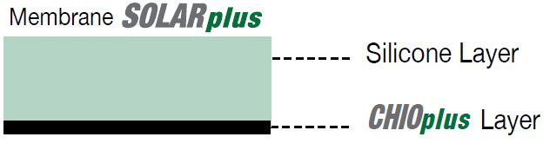  This combination provides longer membrane life, resistance against gas released from EVA films and excellent dimensional stability which translates to more lamination cycles per membrane and an overall excellent price/value ratio.  If interested in learning more, contact your KAM or https://www.chiorino.com/public/files/CHIORINO_Photovoltaic_panels_membrane_SOLAR_PLUS-EN.pdf

Meet The TEAM
Debbie Goddard
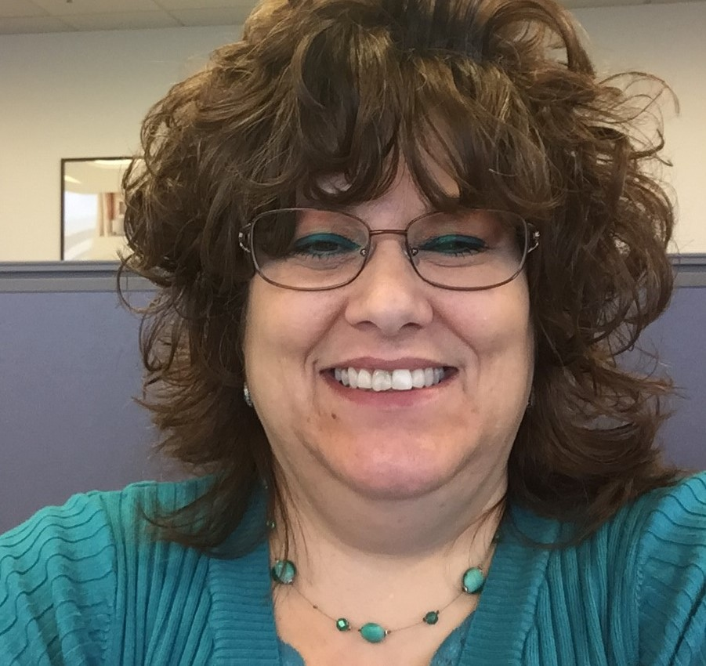
Meet Debbie Goddard, one of our Customer Service Representatives located at our Newark, DE facility. Deb has been with Chiorino for about 2.5 years now and supports several of our Key Account Managers and the customers they are responsible for. She learned about the belting business quickly and now even has a good understanding of our more advanced products like HP Compact Drive.

Our Suwanee facility continues in the growth phase with the additions of heavy duty racking and inventory. One of the pillars of our Distribution strategy is to have the right inventory on hand to support our partners. In a time when so many manufacturers are cutting back, we are investing to support our joint success.

Since the last newsletter we added numerous full rolls into inventory and now have almost 100 in stock with another 42 in transit. Current rack capacity is 144 rolls and we will continue adding to reach the planned storage capacity of more than 300 rolls.
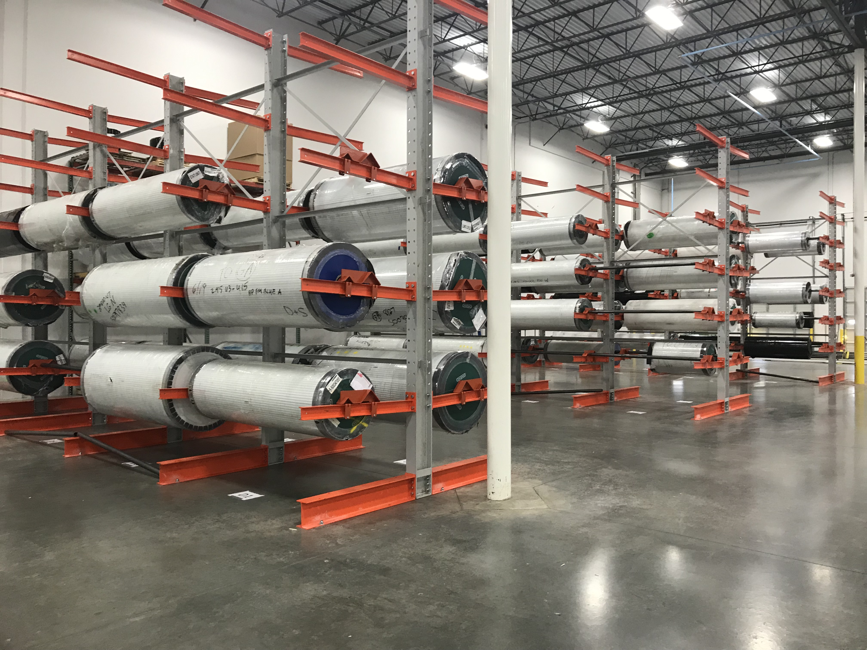

We recently added a longitudinal splicing machine designed in Italy. Next on the list is a new, high-speed v-guide machine capable of welding two guides simultaneously.

Chiorino America Suwanee Facility
Like all our CSRs, Deb enjoys building strong relationships with her customers. She also enjoys multi-tasking and likes a number of different areas of the business including: Purchasing, Admin. and Accounting.
Deb grew up in Massachusetts and worked in the textile industry for over 25 years before relocating to Delaware.
In her spare time, Deb enjoys making crafts and decorating, especially around the holidays. She is also a sports fan and follows the Dallas Cowboys and is also and avid NASCAR fan.

APPLICATION FOCUS
Today’s Distribution Centers have evolved over the past years with newer installations having sortation speeds 30%+ higher than in recent years due to advances in reader technology
Chiorino is pleased to announce the release of three new belts developed specifically for today’s more demanding applications. These three belts cover the majority of the applications and complete our offering for DCs.  The three belts are all built on the same carcass which features a) a low noise construction, to compensate for higher sortation speeds and b) which is 30-50% stronger than most competitors, with a similar flexibility. | The fabrics are engineered for superior lace holding but are also spliced easily if preferred.  One belt is designed with a low friction top cover for accumulation and diverting. Another with a medium friction top cover for horizontal transport and extendible or telescopic conveyors. The third with a high friction, longitudinal groove pattern for inclines, declines and inductions. |  | Sortation speeds of over 300-350 fpm are problematic for standard weave conveyor belts due to the noise generated during operation.
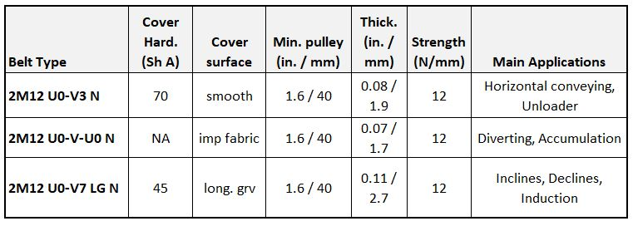
Chiorino America  255 Satellite Blvd NE Ste 100 | Suwanee, GA |30024  125 Ruthar Drive | Newark | DE | 19711  11220 Grader Street Ste 200 | Dallas | Texas | 75238 | For Customer Service and inquiries  302-292-1906  info@chiorino.us  www.chiorino.us  www.linkedin.com/company/chiorino-america/

