|  |  |  |  |
| --- | --- | --- | --- |
|  | Chiorino America Distributor News | | Q4 2018 |
|  |
|  | |  |
| Winning Together with Distribution | | | |
| It might be a lot to ask for you to focus on our entire product line all at the same time so we think we have a good formula down to make it easy to grow your sales of Chiorino products. Every 1-2 months we plan on launching a promotional program for a specific group of products to support our mutual market share growth in different segments.  We’ve refined the process on the second one of these programs and are getting good feedback from our partners. The program steps include: 1) putting the inventory and support materials in place, 2) internal training of our CSRs and Sales Team, 3) announcement of the program to Distribution partners via an email campaign which provides details on the special promotion, and an invitation to a GOTO training on the application and our products, 4) follow-up by our Sales Team with your Team (for joint calls in your region).  The first program focused on our newly released Frayless belt types. | | The current program is based on our DG and DGE folder gluer belts. **We are currently offering a 50% discount on any configuration of belts (ends prepared, endless, coils)** to get our Distributor partners experience with our high-performance belts with minimal risk. We want to partner with you to take share away from those manufacturers who are taking a more direct approach (moving away from distribution) as well as those with lesser performing belts.  Due to the popularity of this program we will be offering a second GOTO training on 12/10 at 4PM EST. To sign up send an email to: [marketing@chiorino.us](mailto:marketing@chiorino.us)  https://gallery.mailchimp.com/71878d86184558c20995641e3/images/dcc2e6d8-6994-4639-b8f0-ab6906ad14b5.pngYou can see these belts and our full product range for Corrugated production in our Sample Card. | **HISTORY CORNER**  In the last issue you read that Chiorino origins were in leather processing.  At the end of the 1950’s Chiorino was compelled to transition away from leather due to developments being made in the chemical industry. The exceptional physical and mechanical performance of plastic materials and synthetic rubber gradually began to replace leather products in power transmission and other applications.  The transition to using the new materials required substantial investment in plants, buildings and an extensive development of the scientific knowledge of the materials and related applications. |

|  |
| --- |
| **Meet The TEAM** |
| Johnny Chambers |

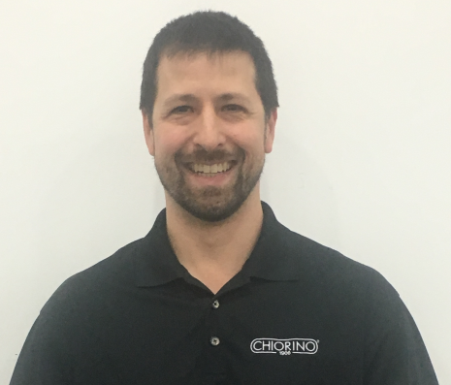Johnny Chambers started with Chiorino America as a **Technical Support Specialist** in August of this year and is located at our Suwanee GA facility. His primary responsibilities are supporting external and internal customers on products and application questions. He has also been involved with updating competitor crossover information and with food approvals for our conveyor belts.

**Chiorino America Suwanee Facility**

Our Suwanee facility is progressing well! We are celebrating each stage of growth as we near shipping fabricated belts which increases our capacity and will decrease lead times. Many changes since the first edition of the newsletter!

Some of the milestones in the facility: 1) got our signage - now we’re legit, 2) held our first sales meeting in the newly decorated training room, 3) installed 1.2 and 2.0 mtr slitting and finger punching lines along with a number of water and air cooled presses, 4) produced our first endless belt (of course it is an HP VL Blue!). We hope that you enjoy growing with us through the pictures and invite you to come see us when possible.

By the next edition of the newsletter in Q1 2019, we will be fully operational!

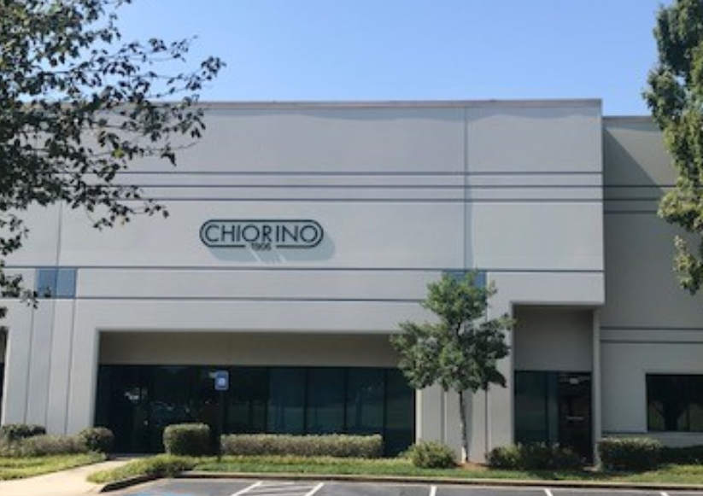 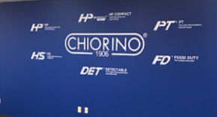

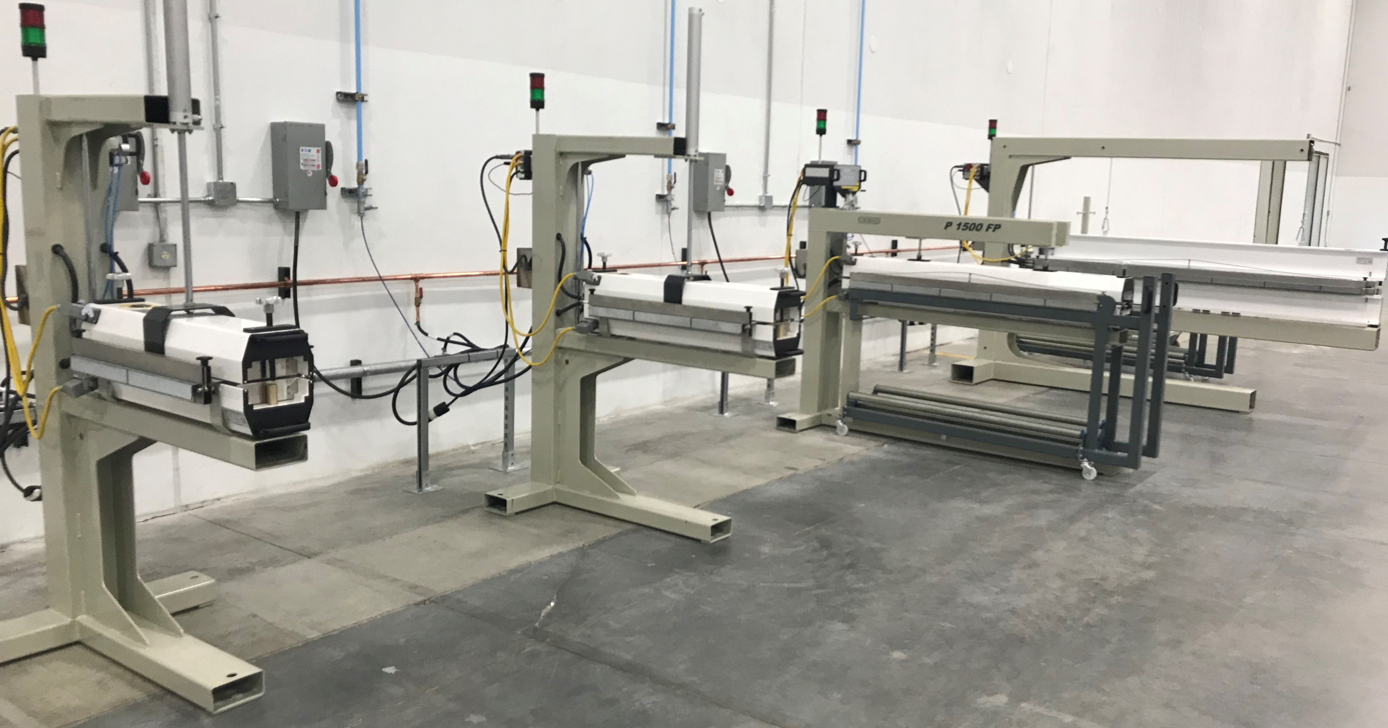 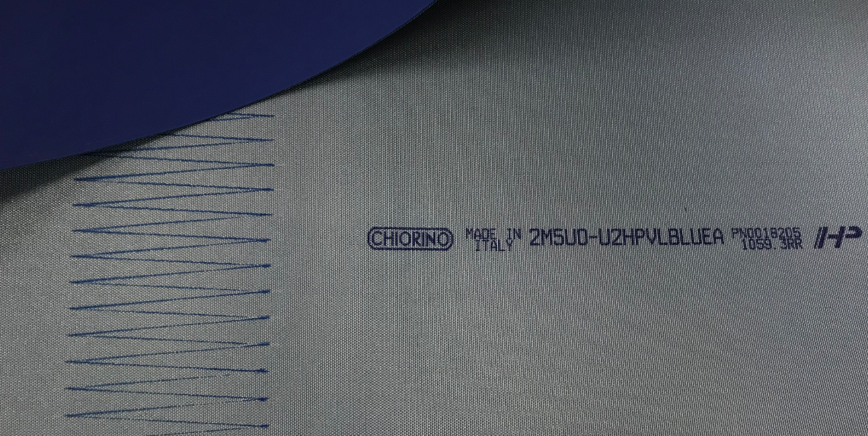

We are also investing in new equipment and process improvements in our Newark, Delaware and Dallas, Texas, facilities.

Prior to coming to Chiorino he worked for over 10 years combined at two different belt manufactures in Customer Service and Technical Support roles. Johnny graduated from Georgia Southern University with a degree in Business Administration, Majoring in International Business and Minoring in Spanish.

Johnny has been married for 19 years and has three children ages: 8,11 and 16.

When he is not working Johnny enjoys exercising, woodworking and spending time with his family. He is well experienced in martial arts with a black belt in Taekwondo, Green/Black in Kenpo and Brown in Yoshukai.

We invite you to get to know Johnny and let him help you with applications or any Chiorino products. Johnny can be reached by phone at **302-292-1906 Ext. 305** or by email at [j.chambers@chiorino.us](mailto:j.chambers@chiorino.us).

|  |  |  |  |  |
| --- | --- | --- | --- | --- |
|  | |  | | |
| APPLICATION FOCUS | | | | |
| The folder gluer is a demanding application due to: the abrasive nature of recycled paper, the torsional forces applied to some belts and the high speeds with small pulley diameters. | | | |  |
| Modern folder gluers run at speeds of over 2000 fpm. High speeds combined with small pulley diameters translate into high flexibility requirements for belts utilized on these machines. The increased use of recycled paper for boxes and the high speeds put abrasion resistance of the rubber covers at a premium.  Chiorino DG and DGE series belts offer a best-in-class combination of strength and flexibility to cope with the demands of today’s high-speed machines.  The DGE belts can be joined with the **Fast Joint** splice with no | adhesives for quick installation and excellent flexibility. The DGE belts are very dimensionally stable due to their construction and are the best choice for high humidity environments. The DG belts are more traditional Nylon core belts which can operate in tough conditions and withstand most jams. These types were recently re-engineered to improve strength and flexibility.  Both types feature the HS rubber which offers best in class abrasion resistance to extend belt life. This rubber maintains a consistent coefficient of friction and won’t crack from the harsh conditions. | | | Demand for corrugated and paper boxes is strong driven by the growth stimulated by Amazon and E-commerce as well as increased demand for pharmaceuticals. |
| PB140008.JPG | | |  | |
| Chiorino America  255 Satellite Blvd NE Ste 100 | Suwanee, GA |30024  125 Ruthar Drive | Newark | DE | 19711  11220 Grader Street Ste 200 | Dallas | Texas | 75238 | | | For Customer Service and inquiries  302-292-1906  info@chiorino.us  www.chiorino.us  www.linkedin.com/company/chiorino-america/ | |